**Step 1:** Selecting the EBS volume you want to delete

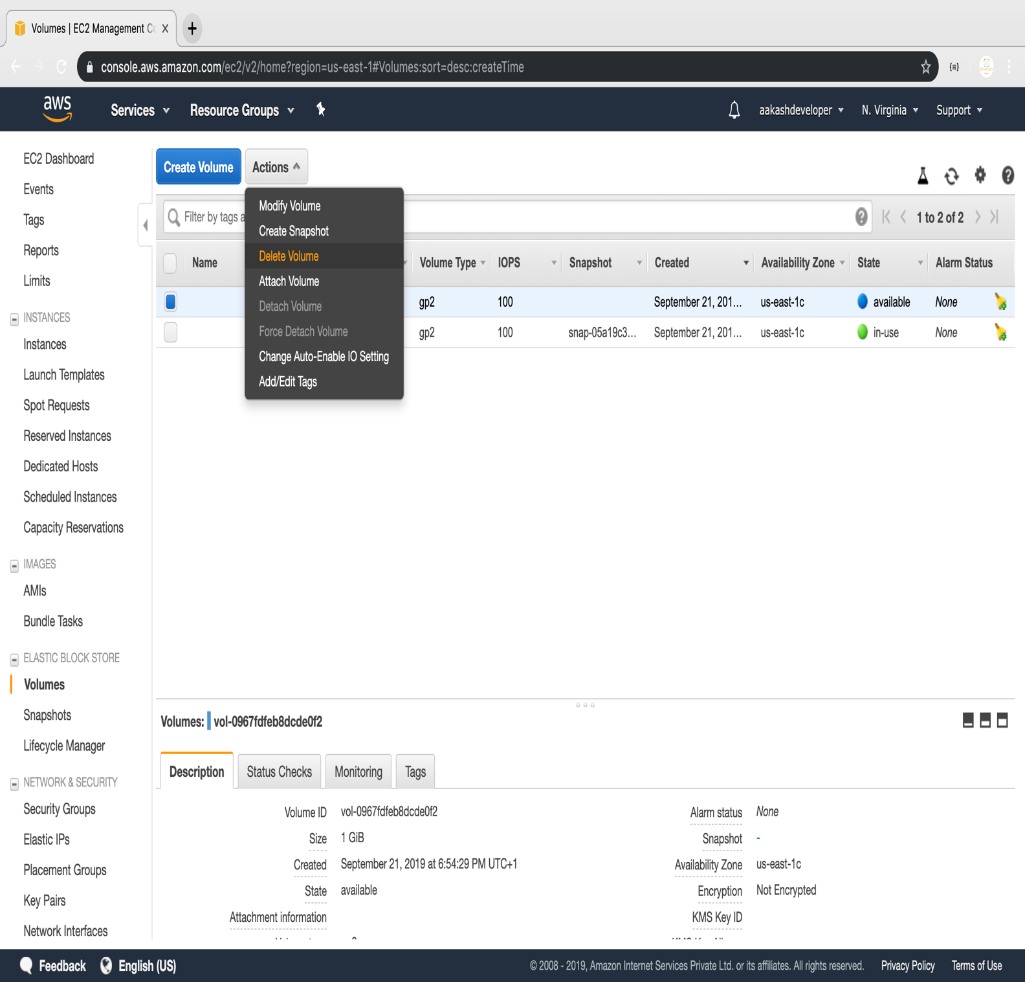

**Step 2:** Deleting the volume

